OZONE Widget Framework
Administrator’s Guide
July 2, 2013

Publication/Revision History
Release | Date
Revised – OWF 7.3 ALPHA | July 2, 2013
Revised – OWF 7.2 | June 11, 2013
Revised – OWF 7 | December 21, 2012
Revised – OWF 6 | September 28, 2012
Revised – OWF 5 | June 29, 2012
Initial Document – OWF 4.0 | March 30, 2012

Contents
1 Introduction 1
1.1 Objectives 1
1.2 Document Scope 1
1.3 OWF Purpose 1
1.4 Supported Browsers 1
1.5 Related Documents 2
2 Administrator Tools 3
2.1 Administrative Managers 3
2.1.1 Manager Panel 4
2.1.1.1 Management Buttons: Create/Delete 5
2.1.1.2 Management Buttons: Edit 5
2.1.2 Manager Widgets—Search 9
2.1.3 Manager Widgets—Pagination 9
2.2 Configurations: User Accounts & Auditing 10
2.2.1 Auditing Configurations 10
2.2.2 User Account Settings 10
2.3 Application Component Approval 11
2.3.1 Approving Required Application Components 13
2.4 User Menu 14
3 Default Content 15
4 Creating and Editing User Content 17
4.1 Creating Users 17
4.1.1 Adding Application Components to a User Profile 17
4.1.2 Adding Users to an Application Component 18
4.1.3 Editing User Properties 18
4.1.4 User Preferences 19
4.2 Creating Applications?? 20
4.2.1 Application Descriptor URL 22
4.2.2 Editing Applications 22
4.2.2.1 Updating and Editing Application Descriptor Data 23
4.2.3 Importing Applications 23
4.2.4 Exporting Applications 24
4.3 Creating Application Components 24
4.3.1 Creating Application Component Intents 25
4.3.2 Application Component Descriptor URL 26
4.3.3 Editing Existing Application Component Content 26
4.3.3.1 Updating and Editing Application Component Descriptor Data 27
4.3.3.2 Editing Application Component Intents 27
4.3.4 Exporting Application Components 28
4.4 Creating Groups 28
4.5 Grouping Application Components 29
4.5.1 Adding Application Components to a Group 29
4.6 Creating Group Applications?? 30
4.7 Connecting to the Store 30
Appendix A Object Reference A-1
A.1 Dashboard Object A-1
A.2 Widget Object A-2
A.3 User Preference Object A-5
Appendix B Known Issues B-1
B.1 Browser Issues B-1
B.2 User Interface Issues B-1
Appendix C Contact Information C-1
Tables
Table 1: Tested Browsers 1
Table 2: Related Documents 2
Table 3: Edit Button and Editor Application Component Fields 6
Table 4: Dashboard Object A-1
Table 5: Widget Object A-2
Table 6: Widget Object Placement A-5
Table 7: Preference Object A-5
Figures
Figure 1: Administrator Tools 3
Figure 2: Users Manager Panel 4
Figure 3: Widgets Tab on the User Editor 6
Figure 4: Management Widget Pagination Toolbar 9
Figure 5: Store Approvals 12
Figure 6: Approvals Widget 12
Figure 7: Required Application Component Identifiers 13
Figure 8: Administrator Drop-down User Menu 14
Figure 9: User Dialog/DEFAULT_USER 15
Figure 10: Default OWF Users Group 16
Figure 11: Preferences Tab 19
Figure 12: Preferences Dialog 20
Figure 13: Reorder Stack Dashboard 23

- Introduction
- Objectives
This guide covers topics relevant to administering the OZONE Widget Framework (OWF).
- Document Scope
This guide is intended for administrators of an OWF instance. An administrator can, for the purpose of this guide, be defined as someone who maintains OWF, as well as handles user and widget settings. In this document, the term “Store” refers both Marketplace and AppsMall. Both applications share features described in this guide and both may be configured to OWF.
- OWF Purpose
OWF is a set of tools, generally delivered in the OWF Bundle. When deployed, OWF is used for organizing and displaying Web applications (widgets) in a single browser window.
- Supported Browsers
OWF supports Internet Explorer 7 and higher and Firefox 3.6 and higher. OWF is tested against the following browsers:
Table 1: Tested Browsers
Browsers | Versions
Internet Explorer | 7 & 9
Firefox | 17
Chrome | 25

- Related Documents
Table 2: Related Documents
Document | Purpose
User’s Guide | Understanding the OWF user interface; adding, deleting, modifying widgets and using widget intents; accessing and using the Store; creating, deleting, adding, switching, modifying applications; using stacks; defining accessibility features such as high-contrast themes and keyboard navigation
Administrator’s Guide | Understanding administrative tools: adding, deleting, and editing app components, users, groups, applications and pages; creating default content for users, groups and group dashboards
Developer’s Guide | Creating Widget applications and integrating existing applications into OWF; widget upgrade instructions; walkthroughs for creating widgets; adding the following components to widgets: intents, descriptor URLs, preference API; logging and launching API
Configuration Guide | Overview of basic architecture and security; OWF installation instructions; instructions for modifying default settings; database set up and logging guidance; framework and theme customization instructions; OWF upgrade instructions; directions for adding and deleting help content
Quick Start Guide | Walkthrough of basic OWF functions such as using widgets, dashboards and stacks; instructions for setting up a local instance of OWF, unpacking the OWF Bundle and installing security certificates; Truststore/Keystore changes
- Administrator Tools
Administration tools, located by clicking the Administration link in the drop-down User Menu (section 19 : User Menu), allow an administrator to manage applications, application component, users and groups. The Configuration tool allows administrators to change select OWF configuration settings from within the user interface. If administrators use the Store Approvals Widget, it will appear here by default.
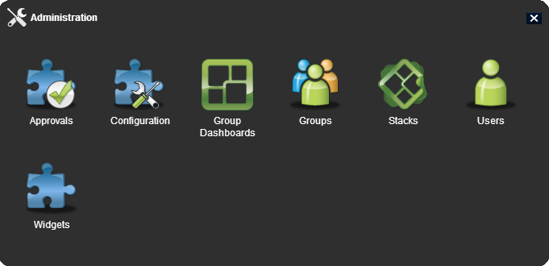
Figure 1: Administrator Tools
- Administrative Managers
The administration managers are used to create, edit and delete users, groups, applications and application components as well as approve listings imported from the Store(s). While each manager has specific fields that relate to the manager’s specific purpose, some of the functions operate identically in each manager. For example, the search feature in the User Manager functions exactly like the search feature in the Widget Manager. Accordingly, search is explained only once in this section.
Also, this document no longer contains definitions regarding basic information that general users should understand. If a topic can be easily defined by Google, it has been removed from this guide. The following section offers a general overview of the administrative managers and their use.
The manager information is broken into sub-sections:
- Panel
- Management buttons
- Search bar and pagination toolbar
- Manager Panel
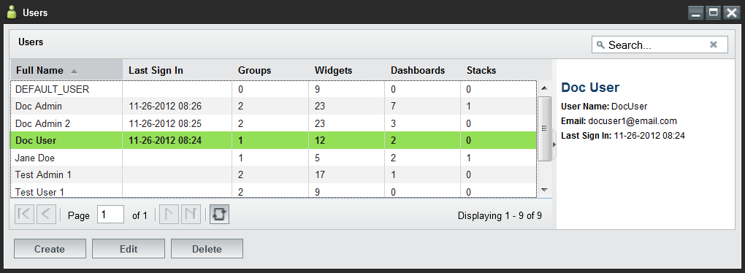
Figure 2: Users Manager Panel
The users, applications (is this manager going to be different?), application components and group managers open to similar panel views. The panel view described in this section applies to all five managers.
The Panel View:
- Allows the user to create, edit, delete or view an entry.
- Displays the number of users/groups/applications/application components associated with the specific entry.
Note: When viewing the application component count, only the application components that a user requests or receives from an administrator appear in the overall count. Application components associated through groups will NOT appear in the application component count.
- Offers a view of the first fifty results in alphabetical order. Additional results can be viewed using the pagination as described in section 12 : Administrative Managers—Pagination. To reduce the number of displayed results: Use the search bar, described in section 11 : Administrative Managers—Search.
From the panel, an administrator can:
- Sort - Most of the columns in the panel can be sorted in ascending or descending order by clicking on the triangle to the right of the column header and selecting a sorting option.
- Hide/Show columns - Columns can be hidden or shown by hovering over a column header, clicking the triangle that will appear, hovering over the columns menu option, and un-checking the columns to be hidden.
- Reorder columns - Columns can be reordered by clicking (and holding) a column header down and then dragging it to the desired position.
- Multiple selection - Entries can be selected for bulk operations by holding down the CTRL button while clicking multiple entries. The delete, edit, activate and deactivate buttons will perform bulk operations on all selected entries.
- View the information panel - To display more information about the entry, single-click the row to open the information panel on the right.
- Management Buttons: Create/Delete
Administrators use the manager widgets to create and delete users, groups, applications and application components. Differences between the five managers are referenced in sub-bullets.
- Opens the editor widget. From the editor, an administrator can create a new user/group/application/application component (depending on which editor the administrator opens) and assign related data to the new entry.
  - When creating a new entry, only the Properties tab will be active until the administrator saves the user/group/application/application component via the Apply button.
- Deletes selected entries. Some user/group/application/application component rules apply:
  - Deleting a group does not delete the users or application components assigned to the group. It only deletes the pairing of users with application components in the group.
  - Deleting an application removes it from the users and groups. Pages and application components that are associated with the application will also be deleted
  - Deleting an application component removes it from a user’s App Components Menu and the groups to which it was assigned.
  - Management Buttons: Edit
- Clicking Edit on any administrative manager will open the respective user/group/application/application component editor, allowing an administrator to edit the entry.
Note: If an administrator starts the editor widgets in a fit dashboard, the editor widgets will “float” on top of the application. Additional application layout information is found in the OWF User’s Guide.
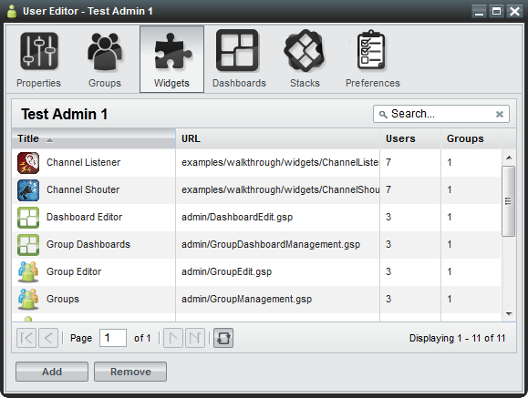
Figure 3: Widgets Tab on the User Editor
From the editor widget, administrators can create, edit and delete data assigned to users/group/applications/application components. The following table alphabetically lists editable fields found in the editor widgets. Split Edit button features, located in the manager widgets, are also listed. The last column of the table describes the location of each field.
Table 3: Edit Button and Editor Application Component Fields
Field | Purpose | Location
Activate/Deactivate | Users in active groups have full access to their group-assigned widgets. Users in a deactivated group will not have access to any of the widgets which are assigned to them via the deactivated group. When a group becomes deactivated it will appear gray.  Note: If a user is in Group A and Group B and each group has Widget 1 assigned to it, the user will still have access to Widget 1 if Group A is deactivated and Group B is activated. Additionally, if the user has widget access outside of a group’s distribution, the user will not lose access to the widget, even if they lose group access. | Group Manager (under the split Edit button);  “Active” checkbox in the Group Editor, Properties Tab
Background | Some application components do not have user interfaces. These application components are often used to cache or log data. If a widget is set to run in the background, it will not appear in the application foreground. Also, it will appear on the user’s App Component Menu if the “visible” menu flag (described in this table) is turned on. | App Component Editor, Properties Tab
Container Icon URL | Defines the location of the icon which appears in app component chrome at 24x24 pixels. | App Component Editor, Properties Tab
Copy To Group | Allows an administrator to copy applications to selected groups via the add groups window. Once an application is added to a group, every member of that group will receive their own copy of that application. | User Editor, Applications? Tab, split Edit button
Definition | A required field in an application that contains the JSON configuration of an application. | Applications? Editor, Properties Tab
Export | Administrators can export stacks to other users as a descriptor URL. Additional information about stack descriptor URLs is available in the Developer’s Guide. | Stack Editor, split Edit button
Display Name | The group name which will appear in grids and tables throughout administrator views. | Group Editor, Properties Tab
GUID | A unique 32-character alpha-numeric code for a particular named widget. If “Widget A” is launched 5 times, all 5 widgets will share the same widgetGuid property. | All Editor Widgets, Properties Tab
Height | Defines the launch height of the application component in pixels. Up and down arrows to the right of the field can be used to modify the overall height. | App Component Editor, Properties Tab
Intents | Application component intents build on OWF’s publish/subscribe functionality by allowing users to choose the application component that will use its data. Intents explain the intention for the widget. This binding capability enables two application components to enhance each other’s functionality. Note: Only developers can modify intents via the widget’s descriptor file; instructions are available in the OWF Developer’s Guide. | App Component Editor, Intents Tab
Favorites Menu Icon URL | Defines the location of the icon which appears in the App Components Menu (at 128 x 128 pixels), provided the “visible” menu flag (mentioned below) is checked. | App Components Editor, Properties Tab
Remove | Separates the selected user/group/application/application component from the selected entry. This does not delete the user/group/application/application component from the system. It only removes the assignment to the selected entry. | All Editors
Singleton | Designates whether an application component can only have one instance opened per application. | App Component Editor, Properties Tab
Universal Name | A value that can be used as a application component’s global identifier across all instances of OWF. This differs from an application component GUID which is unique to a specific installation. | App Components Editor, Properties Tab
URL | Defines the location of the web application to which the application component icon will link. This is a required field. | App Components Editor, Properties Tab
URL Name | A unique stack name/identifier appended to the end of the Stack URL. This is a required field. | Stack Editor, Properties Tab
User Management | Defines whether or not the group is an automatic group, being populated and maintained by external sources. This value cannot be modified once the group has been created. | Group Editor, Properties Tab
Version | Displays the version number of the listing. This is completely user-driven and is for informational purposes. | App Components Editor, Properties Tab
Visible | Dictates whether a listing will show in a user’s App Component Menu. This cannot be overridden by the user. | App Components Editor, Properties Tab
Widget Type | A drop-down menu for selecting the application component type which determines where the application component will be located. Only standard application components appear in the App Component Menu. Administration widgets will appear under the Administration button on the toolbar. Application components set to type “Marketplace” will appear under the Store button on the toolbar. Metric widgets appear under the Metrics in the drop-down User Menu.  Note: Instructions explaining how to associate OWF with a Metrics Service are found in the OWF Configuration Guide. | App Components Editor, Properties Tab
Width | Defines the launch width of the application component in pixels. Up and down arrows to the right of the field can be used to modify the overall width. | App Components Editor, Properties Tab

- Administrative Managers—Search
- Reduces the entries displayed in the panel to entries containing the specified word or characters entered in the search bar. Clicking the X button will clear the filter and display all entries in the panel. Clicking the search magnifying glass button will apply the search and display the filtered results in the panel.
Note: This is a full-text search and it is NOT case-sensitive.
- Administrative Managers—Pagination
Figure 4: Management Widget Pagination Toolbar
- 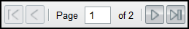 - Navigates between pages of results displayed in the search results panel.
- - Refreshes the results in the search results panel, maintaining the current filtering and sorting options.
- 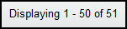 - Displays the number of results being shown against the overall total in the system.
- Administration Configurations
Administrators can configure auditing records, manage user accounts and customize certain branding feature s through the user interface of the Configuration Console. To locate the console:
- Click the Administration link in the drop-down User Menu.
- This opens the Administration Manger. Select Configuration to open the Configuration Console.
Currently, the Configuration Console has three sections accessible to administrators: Auditing, User Account Settings and Branding (). The following sections will further explain each configuration section.
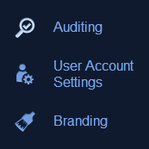
Figure 5: Section of the Configuration Console
- Auditing
To access the auditing configuration settings in the Configuration Console, click Auditing. Click the ON/OFF button to enable or disable auditing.
Common Event Format (CEF) auditing records the following user events: create, edit, delete, sign in, sign out (OWF only), search, import and export. Object Access Auditing will record user’s read events. Object Access Auditing is enabled separately from CEF auditing because auditing “read” events creates an abundance of output records. Separating the two audit features allows administrators to choose the level of detail recorded in the audit logs. For more information on CEF auditing, see the OZONE Store Configuration Guide.
- Common Event Format (CEF) Auditing – When enabled, records a log when users perform any of the following common events, sign in/out, create, edit, delete, search, import and export.
- Object Access Auditing – When enabled, records a log when users perform a read event such as reading a listing.
- User Account Settings
After selecting Configuration from the Administration Manager, the Configuration Console will open to the Auditing section. Click User Account Settings on the left panel to open the user account configurations. These configuration settings are used to control a user’s account:
- Inactive Accounts
  - “Disable Inactive Accounts” – A toggle switch to enable user accounts to be disabled after a period of inactivity.
  - “Set Inactivity Period” – Click on the text field and type in the number of days that need to elapse since a user last signed in before the account is disabled.
When a user’s account is disabled:
  - Application component ownership for the disabled account transitions to “System” so that any application components the disabled user created will not be removed from the instance of OWF.
  - The disabled user’s “last sign in” will be removed. Also removed are the user’s preferences and any reference to that user.
  - If a user signs in after their account is disabled, any of their previous application components, preferences, etc. will not be recoverable.
- Session Control
  - “Session Control” – When set to ON, allows the administrator to set a maximum number of concurrent, active OWF sessions a user can have.
  - “Maximum OWF Sessions per User” – Click on the text field and type in the maximum number of active OWF sessions a user is permitted at one time.
If the Session Control function is turned on and the user exceeds the number of maximum open OWF sessions, the oldest session will be disabled. For example, if the maximum number of active OWF sessions is three and a user opens up four sessions of OWF, the first session the user opened will no longer be active.
- Branding
These

- Application Component Approval
By default, application components are automatically added to a user’s App Components Menu when the user adds them from the Store. The application components will be available for use immediately. However, administrators can configure OWF to store application components in a pending state until they are approved by an administrator. In that case, application components will not be available to users until an administrator approves them.
Note: Find instructions for enabling the Application Component Approvals feature and adding the Approvals Widget in the OWF Configuration Guide.
To approve pending application components, an administrator must navigate to the Approvals Widget by clicking the Administration link in the drop-down User Menu. In the Administration window, click Approvals (Figure 6).
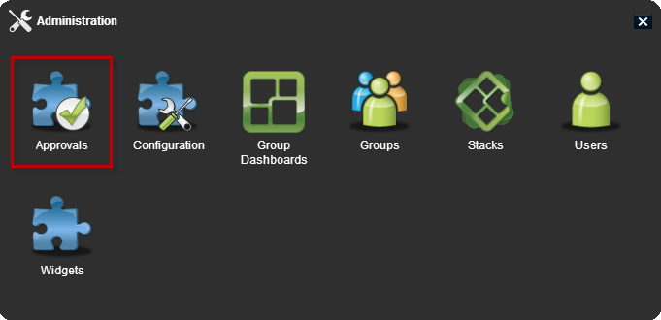
Figure 6: Store Approvals
The Approvals Manager lists all the widgets pending approval. The list can be sorted by App Component or Requesting User.
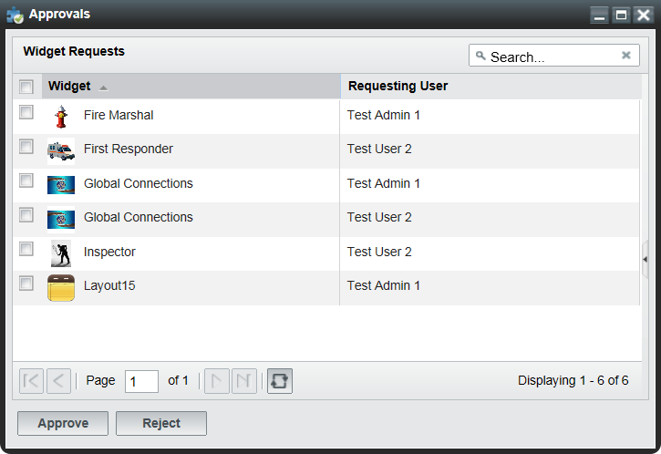
Figure 7: Approvals Widget
To approve or reject widgets:
- Check the checkbox to the left of a pending application component or application components.
Note: Application components must be approved or rejected for each user. Approving an application component for one user will not approve it for another.
- Click Approve or Reject at the bottom of the window.
- After approving the application component, it will appear in the requesting user’s App Component Menu. If a widget is rejected, it will be removed from the Approvals Manager.
- Approving Required Application Components
A Store listing can require other Store listings. For example, if a user requests application component A and it requires application component B, the user automatically requests application components A and B. This relationship is further explained in the OWF User’s Guide.
If the instance of OWF allows users to bypass the pending approval process, those users will immediately receive all requested Store application components along with any required application components that they need.
In the Approvals Manager, an administrator has two ways to identify that a Store listing requires other Store listings. When a listing is selected:
- The details section of the listing will display: Requires App Component: true
- Its requirements will appear below the listing details
Both identifiers are highlighted in the following example:
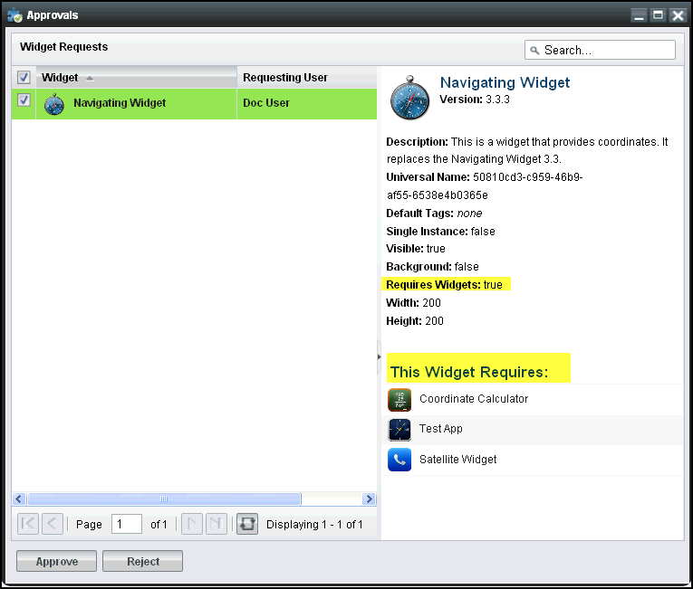
Figure 8: Required Application Component Identifiers
If an administrator approves an application component that requires other application components, the required application components are automatically approved.
- User Menu
The drop-down User Menu is located on the right-side of the OWF toolbar. When OWF is configured to a Store, the administrator User Menu contains additional Store tools than what is found in a user’s User Menu.
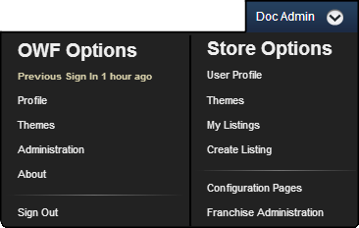
Figure 9: Administrator Drop-down User Menu
OWF and Store Options are described in the OWF User’s Guide (section 2.3 Drop-down User Menu). Additional Store tools an administrator can access are described below:
- Configuration Pages – Opens the Store’s Configuration pages. From here, an administrator can change configuration data through the user interface. More information on the Store Configuration page is found in the OZONE Store Administrator’s Guide.
- Franchise Administration – Opens a list of Affiliated Stores. Administrators can add or remove Affiliated Stores using this feature. See the OZONE Store Administrator’s Guide for more information.
- Default Content
OWF ships with a default user profile and default user group. Administrators can use the default profile and default group to add applications and application components to a user or several users’ instance of OWF.
DEFAULT_USER – A default user profile that ships with OWF. The DEFAULT_USER data will automatically be assigned to every new user of a particular OWF installation.
When a new user enters OWF for the first time, the DEFAULT_USER data will be applied and copied to that user’s profile. After the initial login, any changes that the user makes will only impact their data from that point on. The DEFAULT_USER data remains unchanged and will continue to be applied to all new users.
Note: If an administrator makes changes to the DEFAULT_USER data set, it will only impact the users who log in for the first time, following the change. Any users who received the data prior to the change will not be affected.
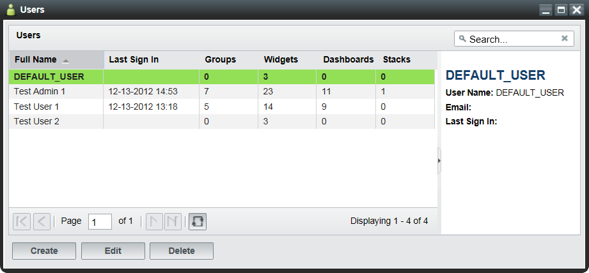
Figure 10: User Dialog/DEFAULT_USER
OWF Users – A default group that ships with OWF. Every new user is automatically assigned to it.
When a new user enters OWF for the first time, the OWF Users group data will be applied and copied to that user’s profile. After the initial login, any changes that the user makes will only impact their data from that point on. However, if an administrator changes the OWF Users Group, the change will be applied to all users who have access to the group.
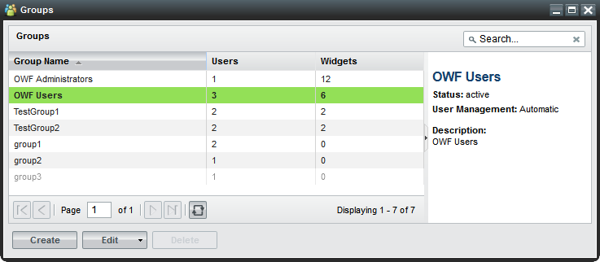
Figure 11: Default OWF Users Group
OWF Administrators - A default group that ships with OWF. Every new administrator is assigned to this group.
Data from the OWF Administrators group is automatically applied to the administrator’s profile. Users cannot be assigned to this group and administrators cannot delete the Editors and Managers populating this group.
Note: The OWF Administrators and OWF Users groups cannot be deleted, renamed or deactivated. In the event that either group is single-selected in the Groups widget, the delete button will be grayed out. If either (or both) groups are selected along with other manual groups, the delete button will be active. However, upon clicking Delete, only the manual groups will be removed from the system. Additionally, the Users tab in the Group Editor widget is disabled for these groups. Any user with access to OWF will receive OWF Users group resources. Any user reported to have an administrative role by the underlying security system will receive OWF Administrators group resources. If these groups are removed from the OWF database, restarting the OWF server will recreate them with no custom applications or application components.

- Creating and Editing User Content
Creating and editing users, groups, applications and application components is explained in this section. This includes adding groups/applications/application components to user profiles through the User Editor. OWF also allows administrators to add users to groups/application/application components through the Users tab on the respective Editors. These examples are described in sections 23 : Adding Application Components to a User Profile and 24 : Adding Users to a.
- Creating Users
Administrators have the ability to create new user profiles, edit existing user information and add groups/applications/application components to user profiles.
To create a new user profile:
- Click the Administration link in the drop-down User Menu.
- Choose the Users button to open the User Manager.
- Click on the Create button, opening the User Editor.
- Enter the user’s information. Mandatory fields (User Name and Full Name) are denoted with a red asterisk. More information about these fields is found in Table 3: Edit Button and Editor Application Component Fields.
- When complete, click Apply. This will activate the additional tabs in the User editor.
- To add groups, applications or application components to a user account, proceed to the instructions in sections 23 : Adding Application Components to a User Profile or 24 : Adding Users to a.
Note: Administrators do not create or maintain user passwords in the OWF interface. Security and authentication are addressed in the OWF Configuration Guide.
- Adding Application Components to a User Profile
The following instructions describe how to add application components to a user account using the App Components tab found in the User Manager. Administrators can follow this basic formula to add groups, application and application components to user profiles via the Groups, Applications and App Components tabs in the User Editor widget. When assignments are complete, all of the data applied to the user profile will be instantly available.
To add application components to a user’s account:
- Click the Administration link in the drop-down User Menu.
- Click the Users button to open the User Manager.
- From the manager, select a User. Then, click Edit to open the User Editor.
- Click the App Components tab at the top of the editor. Application components that are already associated with the user will display in the window.
- To add application components, click the Add button. A modal window will display all application components available to that user. Select an application component, then, click the OK button. The application component is automatically added to the list of widgets on the user’s App Component tab.
- Adding Users to an Application Component
Another way to give users access to application components is to add users to the application component’s profile via the App Component Editor. Again, administrators can use this general procedure to add users to groups and applications through the Users tabs in the respective editors. When completed, close the editor window and the data will be updated automatically to the user profile.
To add users to application component profiles:
- Click the Administration link in the drop-down User Menu.
- Click the App Components button to open the App Component Manager.
- From the manager, select an application component. Then, click Edit to open the App Component Editor.
- Click the Users tab at the top of the editor. Users that are already associated with the application component will display in the window.
- To add users, click the Add button. A modal window will display all users available to that application component. Select a user, then, click the OK button. The user is automatically added to the list of users on the application component’s Users tab and the application component is available to the user’s instance of OWF.
- Editing User Properties
To edit existing user content:
- Click the Administration link in the drop-down User Menu.
- Click Users to open the User Manager.
- From the manager, select a user account to update and click Edit.
- Update data on the Properties tab and click Apply. Update each field, then click Apply. For definitions of less common fields, see section Table 3: Edit Button and Editor Application Component Fields.
This procedure is also used when editing the properties of groups, applications and application components. To edit the content, click the Administration linke in the drop-down User Menu and click on the respective manager and click Edit to open up the editor. Make changes in the Properties tab and click Apply.
- User Preferences
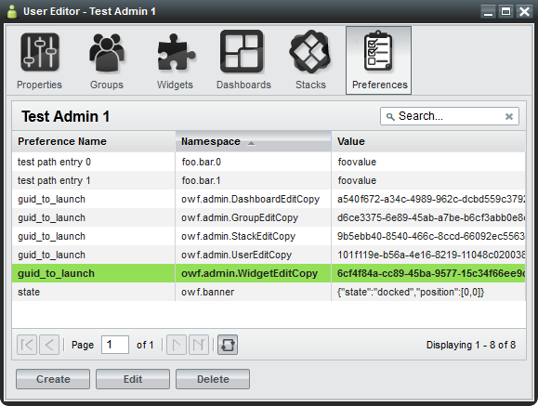
Figure 12: Preferences Tab
Application components use preferences to store data. Preferences include the application component’s location on the screen, instructions to open it, etc. A preference value can be created and saved any time an application component performs an action. Once that preference is saved to the database, it will appear on the Preferences tab in the User Editor. The Preferences tab serves as a table of known preferences. From the tab, administrators can view, create, edit and delete preferences. However, from the Preferences tab, the administrator cannot configure an application component to use a preference. For an application component to respond to preferences, the application component must be configured via the Preference API.
If an application component is configured to use preferences, they can be used to define screen location, application component interaction, etc. For example, the guid_to_launch preference is a useful eventing tool. Administrators can use it to make a Tracking application component open a Map application component. For example, in Figure 12: Preferences Tab, the guid_to_launch preference causes the User Manager to open a copy of the App Component Editor.
The Preferences tab includes the following fields:
- Preference Name - The preference name is referred to as the “key” for the preference item. It lists the name of the preference as dictated by the application component or OWF. If the application component uses preferences, OWF will add the preference name to the table on the Preference tab whenever the action that is associated with the preference is performed.
- Namespace - The namespace is the identifier for the application component or system category. Generally these identifiers will describe general functionality for a application component or set of application components.
- Value - Stored inside of the preference, values house the data that the preference uses. An example could be the actual application component GUID value that the preference will use to open an application component. This is a string value but developers can use JSON or REST URIs as the preference value.
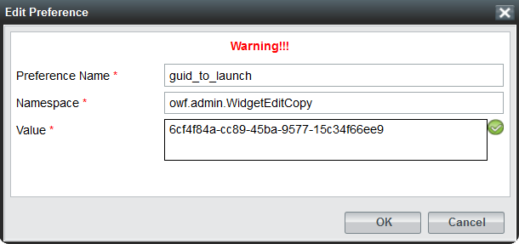
Figure 13: Preferences Dialog
- Creating Applications??
Stacks are a collection of dashboards assigned to multiple OWF users and groups. Administrators have the ability to create, edit, delete, import and export stacks.
Creating, editing and deleting a stack is similar to creating, editing and deleting other features in OWF. Stacks are exported as descriptor files, for instructions see 31 : Importing Applications.
There are several reasons why an administrator may want to share an exported stack. For example, an administrator at Branch A may create a Human Resources Stack. Since this stack is beneficial to everyone at the company, the administrators at other branches may want to use it. Export allows the administrator at Branch A to easily send the stack to administrators from other OWF instances.
From a user’s standpoint:
- Users can add a stack from their franchise store if their OWF is configured to work with the Store.
- Users can customize, restore and delete any stack assigned to them. Those changes will ONLY affect that user’s copy of the stack. Like group dashboards, users can return their stack to the current state of the stack by clicking the button (found by clicking Manage on the Switcher, then choosing a stack).
- If a stack is deleted by an administrator, the user will no longer have a copy of the stack and the dashboards and widgets included in the stack.
- Users cannot delete individual dashboards that are part of a stack, they can only delete an entire stack.
- If an administrator changed the stack and the content of its dashboards after it was added to a user’s instance of OWF, the current state of the stack may be different than the one that originally appeared on the user’s Switcher.
To create a stack:
- Click the button on the toolbar.
- Click on the Stacks button to open the Stacks Manager. Click Create to make a new stack.
- From here there are two ways to create stacks:
  - Import from descriptor URL—Enter a stack descriptor URL and click Load. For more information about stack descriptor URLs see section 28 Application Descriptor URL.
  - Manually enter data—If a descriptor URL is not available, click the “Don’t have a stack descriptor?” link and complete the fields on the Properties tab. For more information about specific entry fields, see Table 3: Edit Button and Editor Application Component Fields.
- Click Apply. This will unlock the Groups, Dashboards, Users and Widgets tabs.
Note: The Widgets tab in the Stacks Editor is for informational purposes only. It displays the widgets available in the stack based on the associated users, groups and dashboards.
- To add an existing dashboard, select the Dashboards tab in the Stacks Editor. Click the Add button. Select a dashboard, then click OK. This method also works for adding users and groups via the Users and Groups tabs in the Stacks Editor.
- Close the Stacks Editor.
Note: Adding an existing dashboard to a stack creates a copy of the dashboard that appears in the Switcher under the same name as the original dashboard. To avoid the confusion of having two dashboards in the Switcher with the same name, administrators are advised to rename duplicate stack dashboards.
- Application Descriptor URL
Like widgets, stacks can be created via a descriptor URL. When stacks are created with a stack descriptor URL, OWF automatically retrieves the stack data from a descriptor file saved in a Web-accessible location. Descriptor URLs allow an administrator to quickly create stacks that have been prepopulated with dashboards and widgets.
Stack descriptor URLs offer several benefits. They can bundle large amounts of stack data (ex. dashboard and widget JSON) into an HTML file. Descriptor URLs allow several installations of OWF to share the same stack information.
- Editing Applications
To edit existing stack content:
- Click on the toolbar, select Stacks to open the Stacks Manager.
- From the manager, select a stack and click Edit.
- Edit the stack data and click Apply.
Users and groups assigned to the stack will receive the stack data changes when the stack is restored via the Switcher.
Administrators can edit the order dashboards appear in a stack. To reorder a stack dashboard:
- Go to the Stack Editor, and click the Dashboards tab.
- Select a dashboard.
- Click or to change the dashboard’s position as shown in Figure 14: Reorder Stack Dashboard.
Users assigned to the stack will see the changes in their Switcher when they log in to OWF or, if they are already signed in, when they Restore the stack.
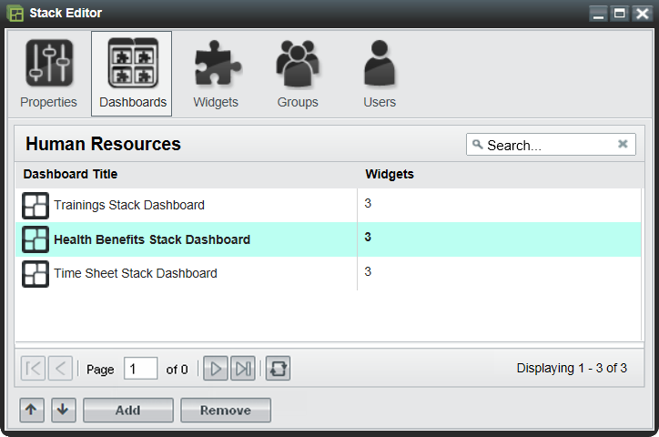
Figure 14: Reorder Stack Dashboard
- Updating and Editing Application Descriptor Data
Administrators who create a stack via a descriptor URL can update and edit the imported stack descriptor data within the OWF interface. Updating the stack descriptor data will retrieve the latest data stored in the stack’s descriptor file. Any changes made to the stack prior to the update are lost.
To retrieve the latest stack descriptor data:
- Click on the toolbar, select Stacks to open the Stack Manager.
- From the manager, select a stack and click Edit.
- Click Load. The Widget Editor will automatically refresh and display the most recent widget descriptor data.
- Click Apply.
Administrator can edit their copy of the stack by following the steps outlined in section 29 : Editing Applications.
- Importing Applications
When any user adds a Stack from the Store, a copy of the stack is added to the OWF Stack Manager. Using this feature might be a timesaving way to add existing stacks to other users’ instances in OWF.
To import a stack:
- Click the button on the OWF Toolbar to open the Store.
- In the Store, use the Search Toolbar at the top of the screen to search for “Stack.”
- Click on a stack listing icon and then click Add button. This action adds the Stack to OWF. One copy of the stack will appear in the Switcher on the toolbar, a master copy will appear in the Stack Manager.
- To add a copy of the imported stack to a user’s account, follow the procedure in section 27 : Creating Applications.
- Exporting Applications
Administrators have the ability to export and save stack data as a descriptor file. An administrator or developer must host the descriptor file in a Web-accessible location to share the file with other administrators. Sharing a stack descriptor URL allows administrators on different OWF systems to have a copy of the same stack.
To export a stack:
- Click the button on the toolbar.
- Click the Stacks button to open the Stacks Manager.
- Click the arrow on the right of the split Edit button and choose Export.
- Enter a File Name, then click OK.
- Move the stack descriptor HTML file to a Web-accessible location, like a shared wikis or company Intranet sites.
- Share the descriptor file URL with other OWF administrators.
Note: Administrators are advised not to edit the stack descriptor file once exported from OWF. Modifying a stack’s descriptor file may introduce code errors that are difficult to identify and will prevent the user from creating the stack.

- Creating Application Components
Administrators can create, edit, delete, import and export application components. There are two ways to create an application component: importing application component data with a descriptor URL or manually entering application component data. Imported application component data is editable through the App Component Editor (see 36 : Editing Existing Application Component Content).
To create an application component, the administrator must complete several mandatory fields in the App Componet Editor. Information about each application component data field is found in Table 3: Edit Button and Editor Application Component Fields. For example, the App Component Type field is useful for separating application components on a user’s toolbar. Only “Standard” type application components will appear in the App Components Menu. “Administration” application components will appear when the Administration link is clicked in the drop-down User Menu. Application components set to type “Marketplace” will appear under the Store button on the toolbar. “Metric” type application components will appear when the Metric link is clicked in the drop-down User Menu.
To create an application component:
- Click the Administration link in the drop-down User Menu.
- Click the App Components button to open the App Component Manager.
- From the manager, click the Create button to open the App Component Editor.
- From here, there are two ways to create application components:
  - Import a descriptor URL—Enter a descriptor URL and click Load. For more information about descriptor URLs see section 35 : Application Component Descriptor URL.
  - Manually enter data—If a descriptor URL is not available, click the “Don’t have a descriptor URL?” link and complete the required fields on the Properties tab. Remember that the application component Type will dictate the location of the application component. For more information about specific entry fields, see Table 3: Edit Button and Editor Application Component Fields.
- Click Apply. This will unlock the Users, Groups and Intents tabs on the App Component Editor. Select each tab and click the Add button to add users, groups and intents to the application component. Information about adding Intents to a widget is in section 34 : Creating Application Component Intents.
- Refresh OWF. The new application component will appear under the respective toolbar button. For more details about connecting to the Store(s), see 44 : Connecting to the Store.
- Creating Application Component Intents
Application component intents are the instructions for carrying out an application component’s intentions. Intents are comprised of an Action (graph, view, edit, etc.), a Data Type (html, text, image, etc.) and a Send/Receive request. If application components have identical Action and Data Types, then the application components that send intents can communicate with the application components that receive intents. For example, the New York Stock Exchange (NYSE) application component sends an intent to graph (Action) daily stock data (Data Type). The Stock Chart application component, having an intent with the same Action and Data Type, receives this request and graphs the data. This binding capability enables the two application components to enhance each other’s functionality. Administrators can add, edit and delete application component intents, however, a developer or someone with experience using intents is more likely to perform these tasks.
Note: Find instructions about using intents in the OWF User’s Guide and instructions about creating intents in the OWF Developer’s Guide. OWF follows standard Web Intent specifications documented at Webintents.org.
To add intents to an application component:
- Click the Administration link in the drop-down User Menu.
- Select App Components to open the App Component Manager.
- From the manager, select an application component to be update and click Edit.
- Click the Intents tab. Click Create to open the Create Intent window.
- Complete the fields, required fields are marked with an asterisk.
  - Action — The Action field is the instruction the intent will make (ex. graph or view).
  - Data Type — The Data Type field indicates the data that the intent is passing from application component to application component (ex. text/html).
  - Send/Receive — This tells the application component to send or receive the application component intent.
- Click OK. The intent has been added to the application component and will be displayed in the Intents tab in the App Component Editor.
- Application Component Descriptor URL
Descriptor URLs allow an administrator to create application components without entering the application component's information manually. The administrator simply enters a URL and the application component's information is automatically retrieved from a descriptor file from a Web-accessible location. Application components created with a descriptor URL are editable in the App Component Editor.
Descriptor URLs offer several benefits. They reduce the risk of typing errors when entering application component data. They allow for several installations of OWF to easily share application component information via the descriptor file.
- Editing Existing Application Component Content
To edit existing application component content:
- Click the Administration link in the drop-down User Menu.
- Select App Components to open the App Component Manager.
- From the manager, select an application component and click Edit.
- Edit the application component data on the Properties tab and click Apply. For definitions of less common application component data fields, see Table 3: Edit Button and Editor Application Component Fields.
Users and groups assigned to the application component will receive the application component data changes automatically.
- Updating and Editing Application Component Descriptor Data
Starting in OWF 7, administrators can update and edit the application component descriptor data within the OWF interface. Updating the application component descriptor data retrieves the latest data in the application component’s descriptor file which is saved in a Web-accessible location. Changes made to the application component prior to the update are lost once the update is performed.
To update the application component descriptor data:
- Click the Administration link in the drop-down User Menu.
- Select App Components to open the App Component Manager.
- From the manager, select an application component and click Edit.
- Click Load. The App Component Editor will automatically refresh and display the most recent application component descriptor data.
- Click Apply.
Administrators can edit their copy of the application component descriptor data by following the steps outlined in section 36 : Editing Existing Application Component Content. Descriptor data changes are sharable after the administrator exports the application component and saves the descriptor file in a Web-accessible location. Individuals who already have access to this application component will have to update their copy of the application component’s descriptor data in order to see the application component changes in their OWF instance.
- Editing Application Component Intents
It is recommended that a developer, or an individual experienced with using intents, edits the application component intents.
To edit application component intents:
- Click the Administration link in the drop-down User Menu.
- Select App Components to open the App Component Manager.
- From the manager, select an application component and click Edit.
- Click the Intents tab, select an intent and click Edit.
- Once changes have been made, click OK. OWF will automatically update the application component data.
- Close the App Component Editor.
Users assigned to this widget will see the changes automatically.
To delete application component intents:
- Click the Administration link in the drop-down User Menu.
- Select App Components to open the App Component Manager.
- From the manager, select an application component and click Edit.
- Click the Intents tab, select an intent and click Delete.
- OWF will automatically update the application component data.
- Exporting Application Components
Administrators can export and save application component data as a descriptor file. An administrator needs to host the application component descriptor file in a Web-accessible location to make the file sharable with other administrators that have access to this location. This process is intended to provide a means for administrators from different OWF instances to add/receive identical application component s.
To export an application component:
- Click the Administration link in the drop-down User Menu.
- Select App Components to open the App Components Manager.
- Select the application component to export. Click the arrow on the right of the split Edit button and choose Export.
- Enter a File Name that describes the application component, this will become the title of the HTML descriptor file. Then click OK.
Note: If the application component was created by a descriptior file, the File Name field will be prepopulated with the descriptor file name.
- Save the application component descriptor HTML file on a Web-accessible server.
- Creating Groups
Groups allow administrators to easily add or remove application and application components to and from multiple users’ instances of OWF. For example, by putting 10 employees into a group, the administrator can send 1 application or 1 application component to the group, rather than having to individually add the application component to ten employees.
The following serves as a walkthrough for documentation purposes only. To create groups in OWF and to add users to that group:
- Click the Administration link in the drop-down User Menu.
- Click the Groups button to open the Groups Manager.
- From the manager, click the Create button. This will open the Group Editor.
- Fill in the appropriate data on the Properties tab. Once the Apply button is clicked, the other tabs on the Group Editor will become active. Note the following:
  - If the display name field is populated, that is the name which will appear in all administrator panels. The only way for the primary name field to appear is to leave the display name field blank.
  - If an administrator checks the automatic box in the User Management field, the following will happen:
    - The name of the group will not be editable.
    - The users tab will remain grayed out as users can only be added via external sources, such as a security plug-ins.
- Add users to the group by selecting the Users tab, clicking the Add button and selecting users from the grid.
- The Applications and App Components tabs behave the same way and can be used to populate groups accordingly.
- Grouping Application Components
The group application and group application component functions allow administrators to quickly and easily give a group of users access to several application components at one time. Application components can be added to a group (see section 42 : Adding Application Components to a Group) and any user added to the group automatically receives access to the group application components.
- Adding Application Components to a Group
When a user is part of a group, for example Group A, the user’s App Components Menu will display the application components assigned to Group A in the main section of the App Components Menu. Only an administrator can make changes to application components that are part of a group. Users cannot edit or delete the group or the application components in it.
To add application components to a group:
- Click the Administration link in the drop-down User Menu.
- Select Groups to open the Groups Manager.
- From the manager, select an existing group and click Edit.
- The Group Editor will open. Select the App Components tab.
- Click Add and select application components to assign to the group. Click OK.
- Close the Group Editor.
- Creating Group Applications??
Group applications allow members of a group to have identical copies of an application. Similar to the OWF Users Group, administrators can use group applications to give different groups of users the same starting screen or access to application components. Each user can customize their instance of the group application. Those changes will ONLY affect that user’s instance of the application. Users can return their application to the current state of the group application by clicking the button (found in the My Apps Menu by clicking Details under the Application’s icon). If an administrator changed the group application after it was added to a user’s instance of OWF, the current state of the application may be different than the one that originally appeared on the user’s navigation bar.
Note: If a group application is deleted by an administrator, the users’ copies of that application will remain available to the users. However, the restore feature will no longer be available for the dashboard.
To create a group application:
- Click the Administration link in the drop-down User Menu.
- Select Groups?? to open the Group Manager.
- Select a group and click Edit.
- To add an application, select the Applications tab and click Add.
- Select the application you want to add, then click OK.
- Close the window. Each user in the selected group will see the application in the My Apps Menu on their toolbar.
- Connecting to the Store
The Store, similar to a commercial application store, operates as a thin-client registry of applications and services. The Store allows administrators to connect to multiple Stores by creating widgets that are stored under the button on the toolbar.
To enable the button on the toolbar, an administrator has to create a “Marketplace” widget. To do this, follow these instructions:
- Sign in to OWF as an administrator.
- Click the button on the toolbar and select Widgets.
- Click Create and complete all the fields, change the Widget Type field to “Marketplace.”
- Click Apply.
- When you refresh OWF, the button will appear on the toolbar. Repeat the process for each different Store connection.

Object Reference

Dashboard Object
Table 4: Dashboard Object
Property | Sample Value | Description
guid | 1d789781-e4e5-5acb-f9c5-eae28adf7699  (A unique 32-character alpha-numeric code) | A unique identifier for the dashboard.  Note: The guid is only required to be unique within the dashboard table.
columnCount | 0 | Deprecated
isdefault | True/False | Legacy Code. This is no longer applicable.
layoutConfig | {  "xtype":  "desktoppane",  "flex": 1,  "height": "100%",  "items": [],  "paneType":  "desktoppane",  "widgets": []  } | Holds the various panes on a dashboard and the widgets inside of the panes, including the widget states.  Note: Appendix A.2 : Widget Object describes the content of “widgets”.
layout | N/A | Deprecated
EDashboardLayoutList | N/A | Deprecated
name | Customizable | This is a User-driven field. Even if a Dashboard loads a default name, the User can modify it at will.
state | N/A | Deprecated
groups | Customizable | When a group is associated with the dashboard, it becomes the value for the “Groups” attribute.
isGroupDashboard | True/False | Identifies if the dashboard is associated with a group.
description | Customizable | A description of the dashboard.
defaultSettings | N/A | Deprecated
createdDate | 02/09/2012 11:48 AM EST | Date when the dashboard was created.
editedDate | 02/09/2012 11:48 AM EST | Date when the dashboard was last edited.
createdBy | userId: “”  userRealName: “” | The user name and id of the dashboard creator.
user | Customizable | When a name is used to validate a security protocol, it becomes the value for the “User” attribute.
alteredByAdmin | True/False | If a user’s dashboard has been modified via the Administration UI, this value will appear as true.

Widget Object
Table 5: Widget Object
Property | Sample Value | Description | Dashboard Layout Type: Accordion, Tabbed, Desktop, Portal, Fit
uniqueId | 1d789781-b4a5-512b-ea59-eae28adf7699 | A unique 32-character alpha-numeric code. representing a widget’s state as it exists on a dashboard instance | All dashboards which contain widgets  Note: This value is not associated with a widget’s state within a dashboard until the widget is launched – then the uniqueId is created.
widgetGuid | 1a718777-b4a5-512b-ea59-eae28adf7699  (A unique per widget 32-character alpha-numeric code) | A unique 32-character alpha-numeric code for a particular named widget. If “Widget A” is launched five times, all five widgets will share the same widgetGuid. | All Widgets
universalName | Ozone.OWF.ChannelShouter | A user-generated, custom identifier which is a permanent element of the widget across multiple instances. This differs from a widgetGuid which is unique to a specific installation. | All Widgets
widgetVersion | 1.0 | A string which indicates the software version of the Widget. | All Widgets
name | “Widget B” | Up to 50 alpha numeric characters. | All Widgets
active | True/False | Dictates which particular Widget on a dashboard is active upon launch. | Tabbed  Desktop
width | 225 | Widget width in pixels. | All Widgets
height | 400 | Widget height in pixels. | All Widgets
minimized | True/False | Dictates whether a Widget is at its minimized size. | Tabbed  Desktop  Floating Widgets
maximized | True/False | Dictates whether a Widget is at its maximized size. | Tabbed  Desktop  Floating Widgets
pinned | True/False | Denotes whether a Widget is pinned in place or not. | Accordion
collapsed | True/False | Denotes whether a Widget is collapsed to its chrome. Dashboard types (on right) are what differentiate this attribute from the minimized definition. | Portal  Accordion
floatingWidget | True/False | Denotes whether a Widget is floating over an entire dashboard and not constrained to a single layout type. Example: Widgets launched from a widget in a fit pane open as floating widgets. | Fit
Column | N/A | Deprecated | N/A
buttonID | N/A | Deprecated | N/A
buttonOpened | N/A | Deprecated | N/A
region | N/A | Deprecated | N/A
The following three values are stored in the database for stateful purposes but are not part of the widget definition or widget creation process. They are used to determine widget placement on a dashboard.
Table 6: Widget Object Placement
Property | Sample Value | Description | Dashboard Layout Type :Accordion, Tabbed, Desktop, Portal, Fit
X | 200 | The ‘X’ value represents the physical location (from the upper left-hand corner of OWF) in which the widget will spawn. | Tabbed  Desktop  Floating Widgets
y | 500 | The ‘Y’ value represents the physical location (from the upper left corner of OWF) in which the widget will spawn. | Tabbed  Desktop  Floating Widgets
zIndex | Variable number | A relative number representing which widget is “on top” of an overlapping cluster of widgets – thus making it the visible widget. | Tabbed  Desktop  Floating Widgets

User Preference Object
Table 7: Preference Object
Property | Sample Value | Purpose
Preference Name | ClockWidgetSettings | User driven – defines the overall preference description. This is the effective key of the preference object that identifies the specific preference.
namespace | TimeType | Used to uniquely identify a widget preference. The OWF team recommends using namespaces similar to java packages, i.e. com.mycompany.widgetname.
value | 24hrMilitary | This value is used to store individual preferences that will be recalled by widget developers. It may consist of any value from a string to a JSON object or REST URI.
userId | testUser1 | The unique identifier of the user to whom this preference belongs.

Known Issues

Browser Issues
Launching any of the Editors (as well as many JavaScript-heavy widgets) in certain versions of Internet Explorer consumes system memory that won’t be flushed or released until Internet Explorer is exited and restarted. Again, this is currently only an Internet Explorer issue.

User Interface Issues
Changes in screen resolution may render widgets unviewable.
The positioning of the widgets is absolute. This means that when changing from a larger monitor to a smaller monitor, or when changing from a higher screen resolution to a lower screen resolution, some floating windows may be either partially or fully off the viewable region of the screen. Currently there is no remedy for this issue.
Internet Explorer users may experience degraded performance.
The latest release of Sencha’s ExtJS 4 JavaScript framework is known to have performance issues in Internet Explorer browsers. The Sencha team is actively working to release a patch to address these issues. Once the patch is released, the OWF team will integrate it into the codebase.

Contact Information
For information about OZONE or access to its resources, please open a ticket regarding the AppsMall Service at http://www.intelink.ic.gov/ticket/secure/CreateIssue!default.jspa and then, email the team at AppsMall@intelink.gov.

Bundle Name / Version OWF-bundle-7.3.zip
CAS.WAR cas.war
OWF.WAR owf.war
Current Version OWF 7.3

